Topic Title: Building Real-Time Management Reporting Packages in Power BI Using Transactional Database Architectures
Database systems do use files for storing the data, but instead of relying on filesystem hierarchies of directories and files for locating records, they compose files using implementation-specific formats. The main reasons to use specialized file organization over flat files are:
Storage efficiency
Files are organized in a way that minimizes storage overhead per stored data record.
Access efficiency
Records can be located in the smallest possible number of steps.
Update efficiency
Record updates are performed in a way that minimizes the number of changes on disk.
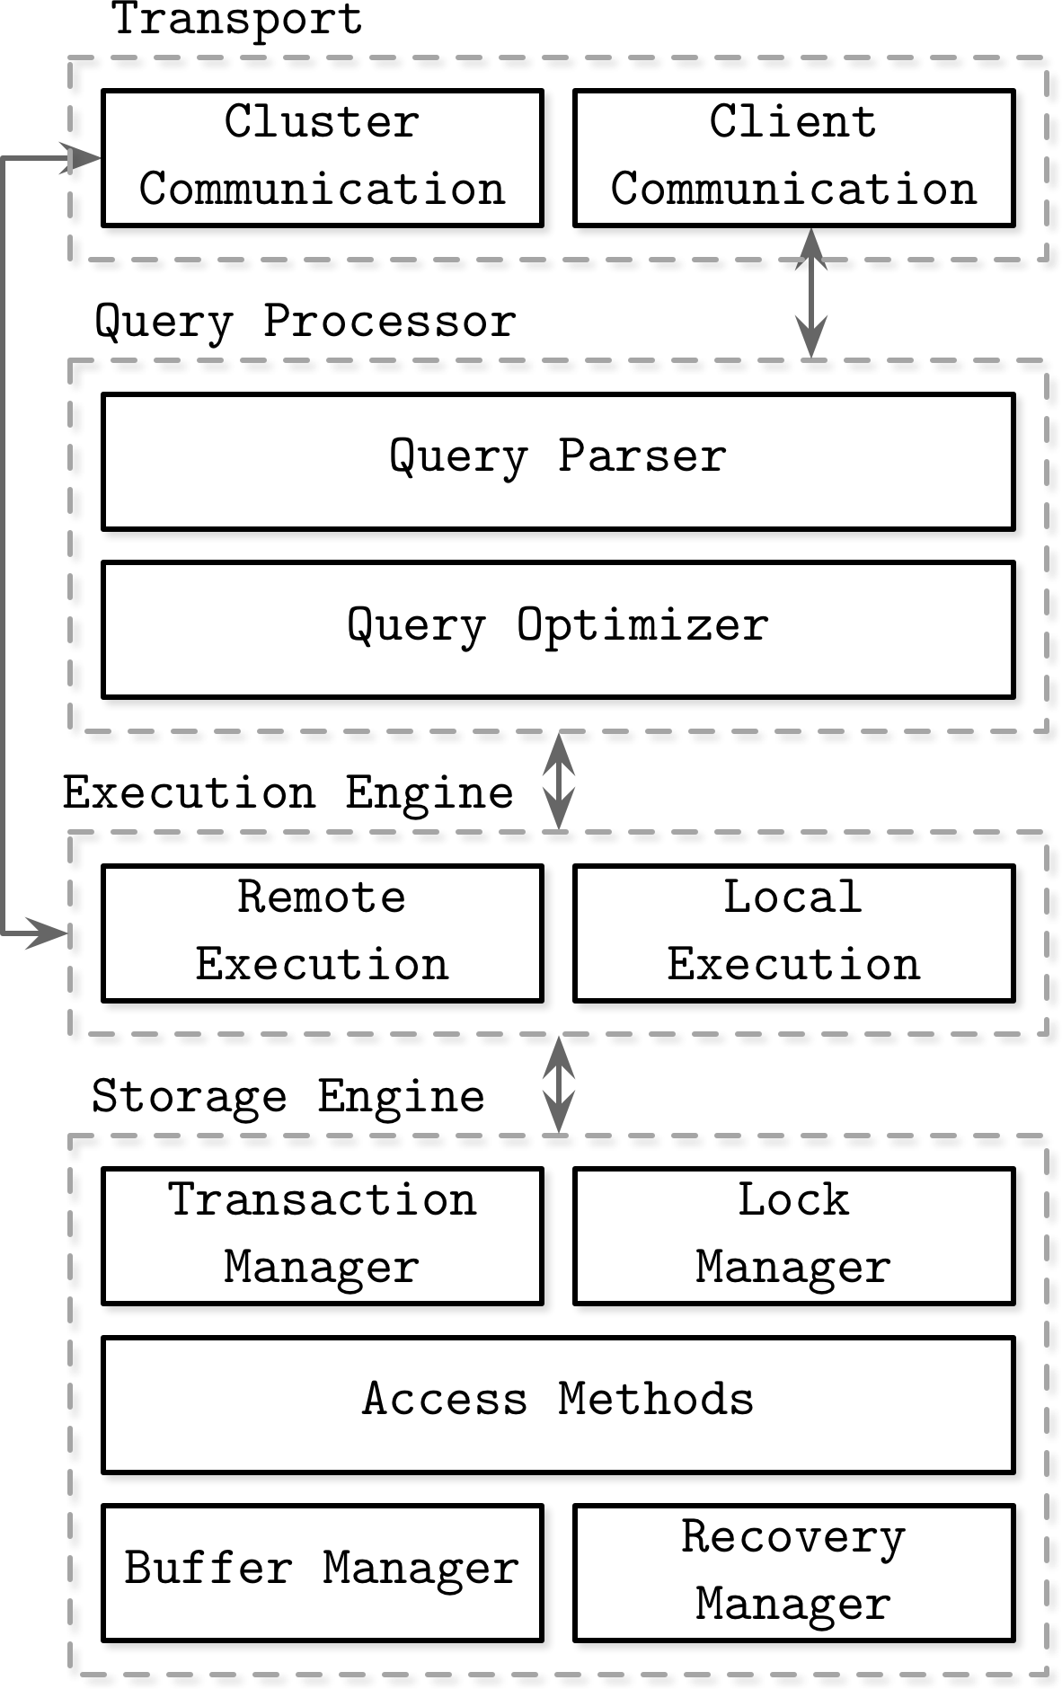
Local queries (coming directly from clients or from other nodes) are executed by the storage engine. The storage engine has several components with dedicated responsibilities:
Transaction manager
This manager schedules transactions and ensures they cannot leave the database in a logically inconsistent state.
Lock manager
This manager locks on the database objects for the running transactions, ensuring that concurrent operations do not violate physical data integrity.
Access methods (storage structures)
These manage access and organizing data on disk. Access methods include heap files and storage structures such as B-Trees (see “Ubiquitous B-Trees”) or LSM Trees (see “LSM Trees”).
Buffer manager
This manager caches data pages in memory (see “Buffer Management”).
Recovery manager
This manager maintains the operation log and restoring the system state in case of a failure (see “Recovery”).
Together, transaction and lock managers are responsible for concurrency control (see “Concurrency Control”): they guarantee logical and physical data integrity while ensuring that concurrent operations are executed as efficiently as possible.₁

- Transitioning Management Reporting from Spreadsheets to Transactional Databases
  - The Operational Bottlenecks of File-Base Workflows
Data analysts who build executive reporting packages often encounter severe tradeoffs when tracking user-supplied productivity metrics. Relying on traditional file-based workflows, such as Microsoft Excel or CSV files, introduces operational bottlenecks that disrupt both data entry operators and decision makers consuming management dashboards:
- Inconvenient Entry Methods & Multi-User Conflicts: Spreadsheet backends lack concurrent multi-user write support. File locking creates inconvenient data entry workflows, forcing users into single-editor access or generating split file copies and save conflicts during simultaneous entries.
- Unsanitized Data Types & Integrity Errors: Flat file stores cannot enforce database-level relational constraints, required field rules, or strict data type validation at the point of entry. Unsanitized inputs lead to severe data integrity errors, broken aggregation measures, and unreliable executive KPIs.
- Refresh Delays and Latency: File-based data sources cannot service on-demand queries in real time. Power BI is forced to rely on scheduled Import mode dataset refreshes, introducing frustrating delays between live user entries and executive dashboard visibility.
  - Architectural Comparison: Unstructured Flat Files vs. Transactional Relational Databases
To establish an executive-grade reporting infrastructure, analysts must transition from ad-hoc flat files to a normalized transactional relational database backend designed for concurrent entry and low-latency analytics:
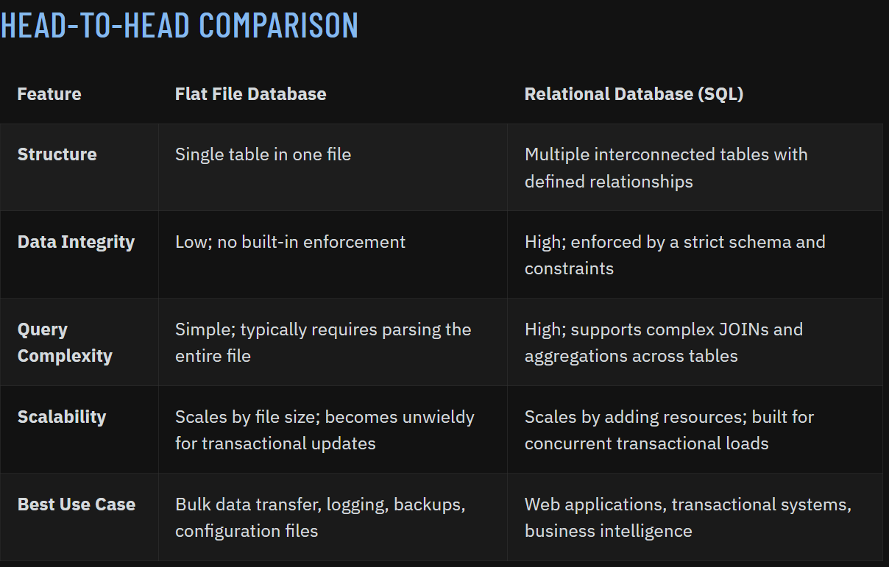₂
Operational Dimension | Unstructured File Backend | Transactional Relational Database (e.g. Azure SQL PostgreSQL)
Data Type Sanitization | Handled manually via visual formatting or macros. Prone to invalid entries | Enforced strictly at the database level via strongly typed column schemes
Data Integrity & Business Rules | Unenforced; high risk of orphaned rows and corrupted metrics | Enforced automatically through primary keys, foreign keys, and check constraints
Multi-User Concurrency | Inconvenient file locking. Frequent concurrency conflicts | Atomic multi-user writes handled safely via ACID transaction management
Power BI Visibility & Refresh | Constrained to delayed, scheduled Import mode model refreshes | Enables on-demand management visibility using real-time DirectQuery execution

  - Technical Framework for Live Management Reporting
Connecting Power BI directly to a transactional database equips data analysts with a robust framework to address management reporting challenges:
    - Translating Business Rules into Database Constraints: By translating organizational productivity rules directly into relational schema constraints, analysts enforce data hygiene before entries enter the reporting layer.
    - On-Demand Management Visibility: Direct database connections allow Power BI to bypass dataset refresh delays, rendering user productivity entries immediately across executive visuals.
    - Secure & Actionable Distribution: Coupling transactional backends with Row-Level Security (RLS) ensures sensitive productivity metrics remain restricted by role, allowing leadership to act on live, sanitized visual summaries with complete data confidence.

- Designing Data Model Schemas for User Productivity Metrics and Executive KPIs
  - Enforcing Data Integrity and Business Rules at the Transactional Backend
When building management reporting packages, data analysts must first establish a secure, reliable foundation for capturing user-supplied productivity data. Rather than relying on error-prone spreadsheet cells or flat files, metrics must be captured in a normalized transactional relational database backend (typically achieving Third Normal Form, or 3NF).
To eliminate data integrity errors and handle concurrent multi-user writes safely, analysts must translate organizational productivity rules directly into database constraints at the engine level (eg. Azure SQL, PostgreSQL):
- Primary and Foreign Key Constraints: Guarantee that productivity metrics cannot be orphaned. Link every submitted entry to a valid, verified user and task category.
- Check Constraints & Strong Data Types: Enforce strict domain rules directly in the database (e.g., CHECK (HoursWorked >= 0 AND HoursWorked <= 24) or ensuring task counts accept only integers) to automatically sanitize user inputs at the point of entry.
- Default Values and Audit Columns: Automatically inject system timestamps (CreatedDate, ModifiedDate) and user session identifiers on insert to maintain a reliable audit trail for compliance and data quality checks.
  - Bridging Transactional Backends to Analytical Reporting Models
Although dimensional models are often instantiated in relational database management systems, they are quite different from third normal form (3NF) models which seek to remove data redundancies. Normalized 3NF structures divide data into many discrete entities, each of which becomes a relational table. A database of sales orders might start with a record for each order line but turn into a complex spider web diagram as a 3NF model, perhaps consisting of hundreds of normalized tables.₂

Once the transactional database enforces strict data integrity in its normalized 3NF structure, data analysts face a fundamental architectural challenge: transactional databases (OLTP) are optimized for row-level inserts, updates, and ACID compliance, whereas Power BI and executive dashboards require aggregated, read-optimized structures.
To bridge this gap, analysts must transition the clean, validated data from the normalized backend into an analytical model suitable for high-performance reporting. This ensures that user-supplied metrics—such as task completion counts, hours logged, and performance scores—are separated from descriptive metadata like user profiles, department hierarchies, and calendar dates.
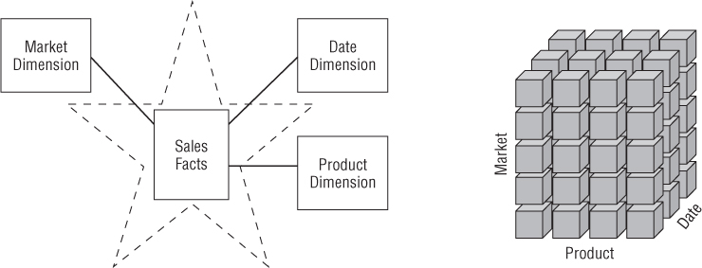
₂
  - Relational Schema Design: Fact and Dimension Architecture for Power BI
To prepare the data for Power BI consumption and avoid the query performance bottlenecks of joining multiple 3NF tables, analysts should structure the reporting model using dimensional modeling principles (star schema design):
    - Productivity Fact Tables: The core analytical table containing quantitative, additive, and semi-additive user metrics (e.g., TasksCompleted, TaskDurationSeconds, ErrorCount) alongside foreign keys pointing to descriptive dimensions. Every user submission generates an atomic row tied to a specific timestamp, user ID, and task category.
    - User/KPI Dimension: Stores worker profiles, employment status, reporting lines, and organizational tiers, which serve as the foundation for both management reporting roll-ups and Row-Level Security (RLS) enforcement.
    - Calendar Dimension: Essential for time-series analysis, enabling management to evaluate productivity trends across daily, weekly, monthly, and quarterly intervals without relying on volatile database functions.
  - Optimizing the Data Model for Power BI Consumption
Once the reporting schema is established, analysts must configure the data model to ensure responsive performance in Power BI:
    - Star Schema Transformation: In Power BI, relationships should be configured in a clean one-to-many ($1:*$) topology, with dimension tables filtering the central productivity fact table.
The final step of the ETL process is the physical structuring and loading of data into the presentation area's target dimensional models. Because the primary mission of the ETL system is to hand off the dimension and fact tables in the delivery step, these subsystems are critical. Many of these defined subsystems focus on dimension table processing, such as surrogate key assignments, code lookups to provide appropriate descriptions, splitting, or combining columns to present the appropriate data values, or joining underlying third normal form table structures into flattened denormalized dimensions. In contrast, fact tables are typically large and time consuming to load but preparing them for the presentation area is typically straightforward. When the dimension and fact tables in a dimensional model have been updated, indexed, supplied with appropriate aggregates, and further quality assured, the business community is notified that the new data has been published.₃
    - Surrogate Keys vs. Natural Keys: Utilize integer surrogate keys in database relationships to optimize join performance and reduce memory consumption during cross-table filtering in Power BI.
    - Pre-Aggregations and Calculated Measures: Avoid storing pre-calculated totals in the transactional database; instead, leverage DAX (Data Analysis Expressions) to dynamically aggregate user metrics on the fly,

- Optimizing Power BI Storage Modes (DirectQuery vs. Import) for Management Dashboards
- Implementing Row-Level Security (RLS) to Control Data Access Across Management Levels
- Packaging and Distributing Executive Reporting Packages with Automated Data Quality Checks.

Credible Sources:
- Database Systems: Concepts, Design and Applications, 2nd Edition https://learning.oreilly.com/library/view/database-systems-concepts/9788131760925/
- Source table used in Section 1https://batchdata.io/blog/flat-file-database
- Chapter 1 of The Data Warehouse Toolkit as it pertains to BI https://learning.oreilly.com/library/view/the-data-warehouse/9781118530801/9781118530801c01.xhtml#c01_level1_4

